Spring Notes

Spring Framework implements lot of design patterns required to develop the applications like

* Dependency Injection
* Singleton pattern
* Front controller pattern
* Proxy pattern
* Factory pattern

Old Approach

EmployeeDao.java

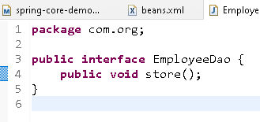

JdbcImpl.java

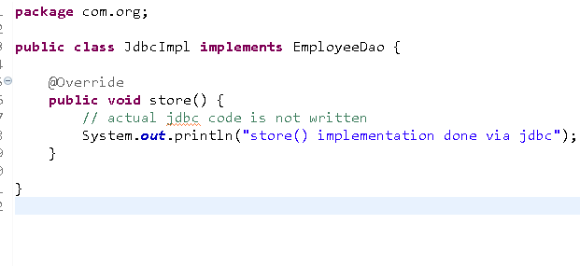

MainApp.java

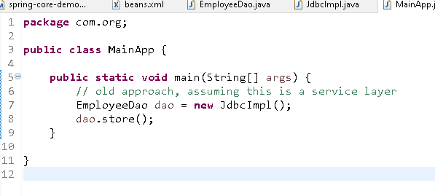

Output:

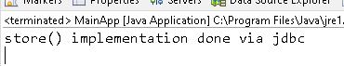

Suppose a new implementation you want to use then you must change the dependency code, which can be completely avoided through spring dependency injection feature

Dependency Injection: process of supplying the dependency to other objects

New Approach:

Mention the dependencies to be created in an xml file and use ApplicationContext to load the xml file that enables spring to create the object of all the classes present in the xml

beans.xml

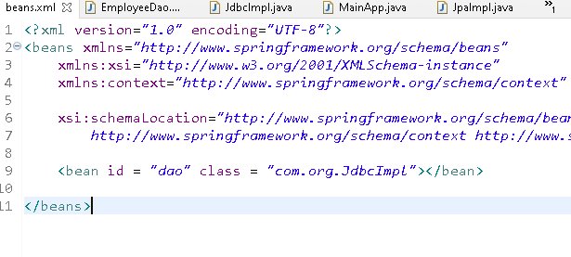

MainApp.java

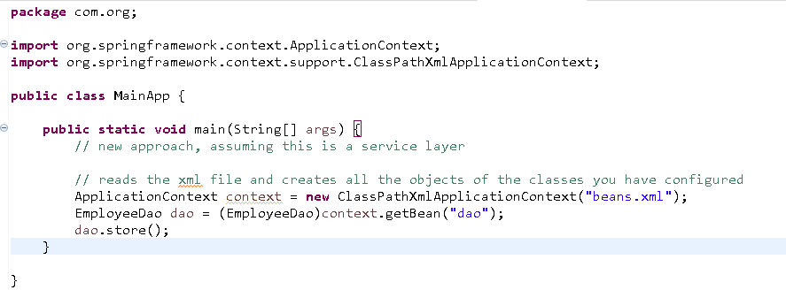

Output:

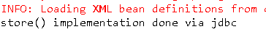

Changing the xml to get JpaImpl

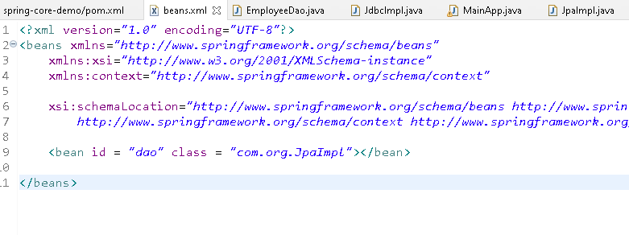

Output:

